Aayush Hitesh Sanghvi Yogi Hetal Shah
REPORT

1. Detect and Extract Target Corners:
For this project, I have used chessboard image as my target image.

Limitations for using chessboard image- Chessboard corners are very sensitive to light. When you try to move the camera to a horizontal angle, the black part of the image gets bright because of the light and thus the chessboard corners are not detected at such an angle as shown in the image below.
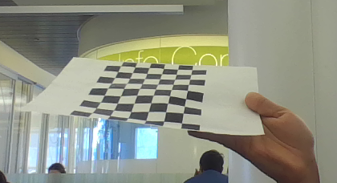

2. Select Calibration Images
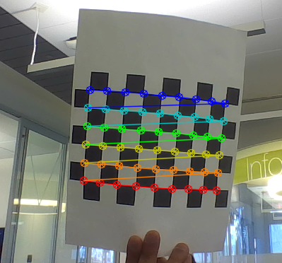

3. Calibrate the Camera:

Chessboard Camera Matrix:
638.043, 0, 209.102,
0, 652.751, 332.422,
0, 0, 1,

Chessboard Distortion Coefficients:
-0.766928, 7.71677, -0.050879, 0.0244049, -29.6045,

Chessboard Re-projection Error: 0.637633

Chessboard Rotational Matrix:
2.28542, 2.12526, -0.193161,
2.28419, 2.11398, -0.231654,
2.27504, 2.10868, -0.251891,
2.27993, 2.10707, -0.252141,
2.27889, 2.10907, -0.244202,
3.01605, 0.0455666, -0.397811,
2.97567, 0.078098, -0.465911,
3.01127, 0.0783233, -0.409329,
2.9967, 0.0842671, -0.430241,
3.01233, 0.0942675, -0.396916,
3.00319, 0.0930337, -0.405263,
3.00542, 0.0924027, -0.398088,
3.00023, 0.0925384, -0.392966,

Chessboard Translational Matrix:
1.79733, -5.47022, 65.213,
1.72428, -5.58683, 65.7729,
1.78379, -5.55042, 66.1833,
1.71383, -5.54412, 66.3102,
1.67769, -5.52797, 66.4943,
-4.34322, -3.35891, 72.9454,
-3.89986, -3.34315, 73.7527,
-4.11411, -3.33895, 73.5862,
-4.09693, -3.29732, 73.8331,
-4.08702, -3.1766, 73.0373,
-4.12572, -3.19066, 73.3975,
-4.17757, -3.20203, 73.6449,
-4.20732, -3.18518, 73.7468,

4. Calculate Current Position of the Camera:
I have printed out the rotational and translational matrix of the camera in real time. The camera position was set stationary here.
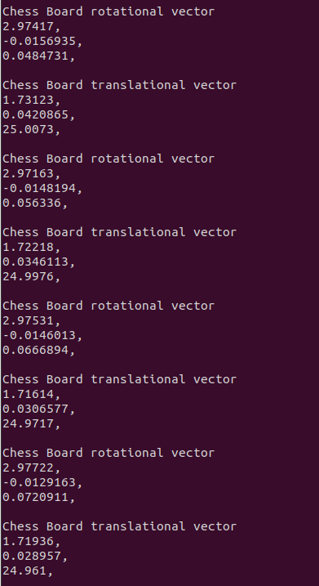

The below two images shows the camera angle and the rotational and translational matrix for that particular camera angle.

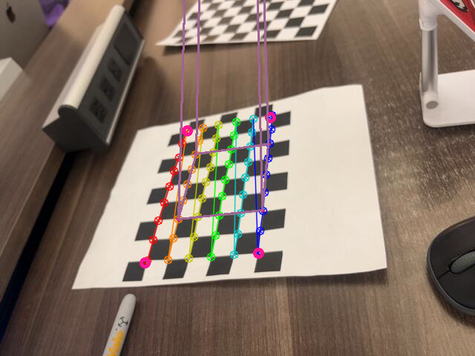
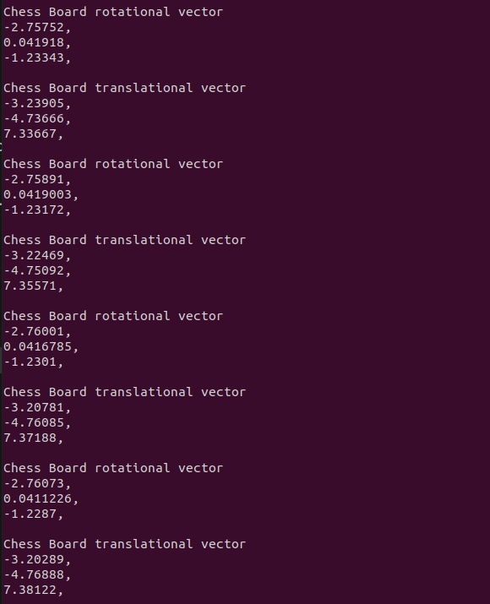

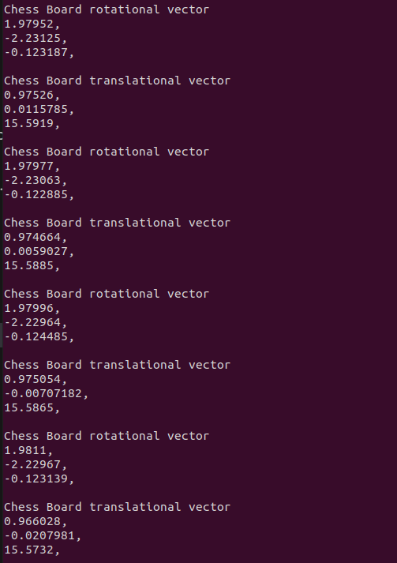

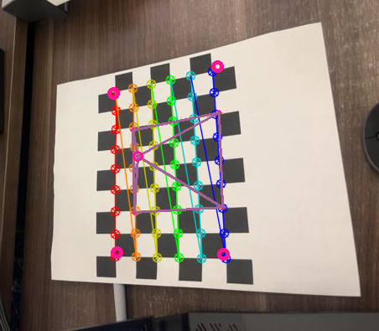

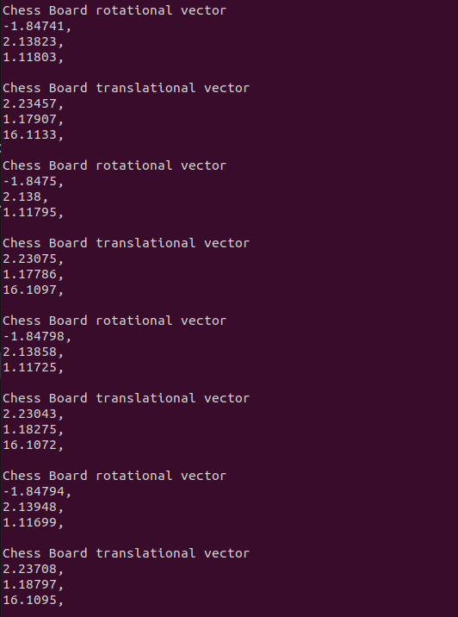

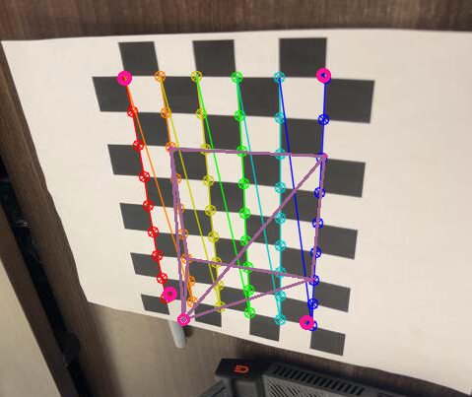

We can notice the difference in the rotational and translational matrix of the camera at different angles.

5. Project Outside Corners or 3D Axes
I have projected the outside corners with pink circles as shown below.
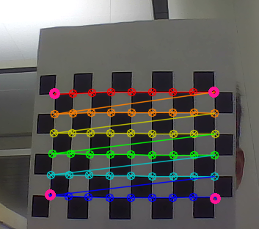

6. Create a Virtual Object
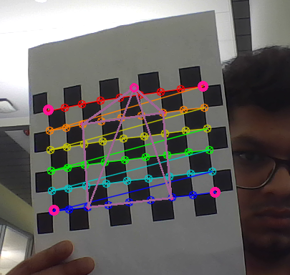
I have created a pyramid with a circle on the top as shown in the image below.

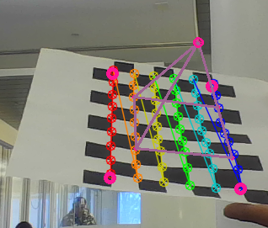

7. Detect Robust Features
For this task, I have implemented Harris Corner Feature detection.

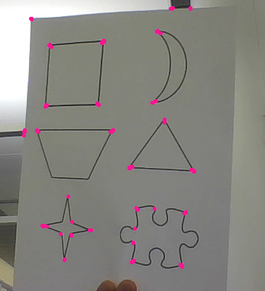

For this task, we can first extract the corner points using Harris Corner feature detection algorithm, once we get the feature points, we need to track those feature points and then estimate the camera pose relative to the object by using PnP techniques. Using the estimated camera pose, we can extract the 3D cordinates of the feature points and overlay a virtually created object onto the image to achieve augmented reality.

Extension-1:
Test out several different cameras and compare the calibrations and quality of the results.
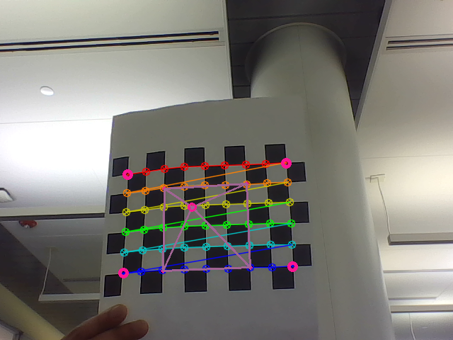
Laptop in-build webcam:
Chessboard Camera Matrix:
649.344, 0, 340.144,
0, 655.365, 275.33,
0, 0, 1,

Chessboard Distortion Coefficients:
-0.414357, 1.6626, 0.00502328, -0.0382924, -6.70371,

Chessboard Re-projection Error: 0.376407

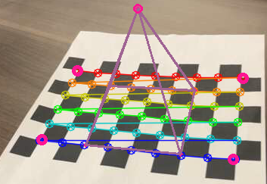
Mobile phone camera(iPhone):
Chessboard Camera Matrix:
756.394, 0, 239.43,
0, 934.667, 297.969,
0, 0, 1,

Chessboard Distortion Coefficients:
-0.707133, 86.7442, -0.0982086, -0.0917287, -1257.34,

Chessboard Re-projection Error: 1.22501

